**Software Requirements Specification**

**Team Wow**

**Product: Sensory Evaluation Website**

**Helping food science with data gathering and analysis software**

**Team members:**

**Connor Taylor**

**Shaina Greer-Short**

**Frank Senseney**

**Geoff Worley**

**2/7/2018**

**Table of Contents**

Table of Contents………………………………………………………………………………………………………………………….…….. 2

1. Introduction…………………………………………………………………………………………………………………….………… 6
   1. Purpose…………………………………………………………………………………………………………………....………… 6
   2. Scope…………………………………………………………………………………………………….………………….………… 6
   3. Definitions, acronyms, and abbreviations…………………………………………….………………..…..…….… 6
   4. References……………………………………………………………………………………..……….………………..………… 6
   5. Overview……………………..………………………………………………………………………….………………..………… 7
2. Overall Description……………………………………………………………………………………….………………..….……… 7
   1. Product Perspective……………………………………….……………………………………….…………..……..….…… 7
      1. System Interfaces……………………………………………………………………….…………..……..….…… 7
      2. Interfaces……………………………………………………………………….…………..……..….………………. 7
      3. Software Interfaces……………………………………………………….…………….……..….………………. 8
         1. Microsoft Excel 2010………………………………………..…….…………….……..….………………. 8
      4. Communication Interfaces……………………………..……...…….…………….……..….………………. 8
         1. Transmission Control Protocol……………………………..……...……………..….………………. 8
         2. Internet Protocol…………………………………………………….…………….……..….………………. 8
      5. Memory Constraints…………………………………………………….…………….….…..….………………. 8
      6. Operations………………………………………………..………………….…………….……..….………………. 8
      7. Languages………………………………………………..………………….…………….……...….………………. 8
      8. Frameworks……………………………………………..………………….…………….……..….………………. 8
      9. Server………………………………………………..………………….…………….……..….………………………. 8
   2. Product Functions…………………………….……..……...……………………………………………..….………………. 8
      1. Create Accounts…………………………….…...……………………………………………..….………………. 8
      2. Create Tests…………………………….…...……………………………………………..….………….…………. 9
      3. Copy Tests…………………………….…...……………………………………………..….………….……………. 9
      4. Types of Tests…………………………….…...……………………………………………..….…….……………. 9
      5. Amount Right…………………………….…...……………………………………………..….……….…………. 9
      6. Multiple Factors…………………………….…...……………………………………………..….………………. 9
      7. Reference Sample………………………….…...……………………………………………..….………………. 9
      8. Change Variables…………………………….…...……………………………………………..….…….………. 9
      9. Type of Scale…………………………….…...……………………………………………..….………………..…. 9
      10. Point Value of Scale…………………………….…...……………………………………………..….…………. 9
      11. Descriptive Terms…………………………….…...…………………………………………..….………………. 9
      12. Random Three Digit Codes…………………………….…...…………………………………………………. 9
      13. Document of Codes…………………………….…...………………………………………..….………………. 9
      14. Judge Interface…………………………….…...………………………………..……………..….………………. 9
      15. Random Sample Order…………………………….…...…………………….……………..….………………. 9
      16. Save Data…………………………….…...…………………………………………………..…..….………………. 9
      17. Example Page………………………………………………………………………………..…..….……….……. 10
      18. How-To Page…………………………….…...……………………………………………..…..….……….……. 10
   3. User Characteristics…………………………….……..……...…………………………………………….………………. 10
   4. Constraints…………………………….……..……...……………………………………………………………….…………. 10
   5. Assumptions and Dependencies………………………………………………………………………………….……. 10
   6. Apportioning of Requirements…………………………….……..……...……………………………………………. 10
      1. Stage 1…………………………….……..……...........................……………………………………………. 10
         1. Create Tests…………………………….…...………………………………..….……..…….…………. 10
         2. Intensity Tests…………………………….…...…………………………………..….….….…………. 10
         3. Multiple Factors…………………………….…...…………………………………….….……………. 11
         4. Change Variables…………………………….…..…………………………………..….…….………. 11
         5. Type of Scale……………………….…...……………………………………..….……………..…..…. 11
         6. Point Value of Scale…………………………….…...……………………………..……...…………. 11
         7. Descriptive Terms…………………………….…...………………………………..…...……………. 11
         8. Random Three Digit Codes……………………….…………………………………………………. 11
         9. Document of Codes………………………………………………………………..….………………. 11
         10. Judge Interface………………………………………………..……………..….………………………. 11
         11. Random Sample Order…………………………………….……………..………….………………. 11
         12. Save Data…………………………………………………………………..…….….………..……………. 11
         13. Create Accounts……………………………………………………………………..….………………. 11
      2. Stage 2…………………………….……..……...……………………………………………………………………. 11
         1. Reference Sample………………………….…...……………………………………..….………………. 11
         2. Triangle Test………………………….…...……………………………………..….………………………. 11
         3. Duo/Trio Test………………………….…...……………………………………..….…………….………. 11
      3. Stage 3…………………………….……..……...……………………………………………………………………. 11
         1. Copy Tests…………………………….…...…………………………………..……………….……………. 11
         2. How To Page……………………………………………………………..…..….……………….………. 11
         3. Example Page……………………………………………………………..…..….………………………. 12
         4. Amount Right…………………………….…...………………………………..….………...…………. 12
3. Specific Requirements…………………………….……..……...…………………………………………………………….…. 12
   1. External Interfaces…………………………….……....…………………………………………………………….………. 12
      1. CWU Username…………………….……..…….……………………………………………….……….………. 12
      2. CWU Password…………………………….……..………………………………………………………….……. 12
      3. Name Test…………………………….……..……………………………………………………………..….……. 12
      4. Description Test…………………………….……..…………………………………………………….….……. 12
      5. Type Test…………………………….……..…………………………………………………………………….….. 12
      6. Number of Samples…………………………….……..…………………………………………………..……. 12
      7. Variable being Tested…………………………….……..………………………………………….….………. 12
      8. Reference Sample…………………………….……..…………………………………………….………….…. 12
      9. Description of Variable…………………………….……..………………………………………………..…. 13
      10. Type of Scale…………………………….……..…………………………………………………………….……. 13
      11. Number of Points…………………………….……..……………………………………………………………. 13
      12. Descriptive Terms…………………………….……..………………………………………………..…………. 13
      13. Add Variables…………………………….……..…………………………………………………….……………. 13
      14. Name Judge…………………………….……..……………………………………………………………………. 13
      15. Date Judge…………………………….……..………………………………………………………………………. 13
      16. Score Judge…………………………….……..…………………………………………………………….………. 13
      17. Excel…………………………….……..……………………………………………………………………….………. 14
      18. Random Digits…………………………….……..………………………………………..………………………. 14
   2. Functions…………………………….……..……………………………………………………………………………….……. 14
      1. Validity…………………………….……..………………………………………..……………….…………………. 14
      2. Sequence of Operation…………………………….……..………………………………..…………………. 14
      3. Incorrect Inputs…………………………….……..……………………………………..………………………. 14
      4. Error…………………………….……..………………………………………..…………………………..…………. 14
      5. Save Data…………………………….……..………………………………………..…………………..…………. 14
   3. Logical Database Requirements….………………………..……………………………………………..……………. 14
      1. Users Table….………………………..…………………………………………………..…………..……………. 14
      2. Tests Table….………………………..…………………………………………………………..…………………. 14
      3. Variables Table….……………………..……………………………………………..…………………….……. 14
      4. Individual Variable Tables….……………………….…………………………………………..……………. 14
   4. Software System Attributes…………………………….……..………………………………..……………….………. 15
      1. Reliability…………………………….……..………………………………………………..………………………. 15
         1. Percent Work Correctly…………………………….……..…………………..……………….………. 15
         2. Percent Time Work Correctly…………………………….……..……………..…………….………. 15
      2. Availability…………………………….……..………………………………………………..……………………. 15
         1. Time…………………………………………….……..………………………………..……………….………. 15
         2. Failure………………………………………….……..………………………………..……………….………. 15
         3. Shutdown…………………………….……..………………………………………..……………….………. 15
   5. Views………………………………………………………………………………………………..………..…….………………. 15
      1. User Class………………………………………………………..…….…………………………………….………. 15
         1. Administrative User……………………………………………………………………………….………. 15
         2. Account User…………………………………..………..…….…………………………………….………. 15
         3. Non-Account User…………………………………………..…………………………………….………. 15
   6. Requirements Check………….………..………..………..…….……………………………………………..….………. 15
      1. Feasibility………….……………………………..……....…….……………………………….………….………. 15
      2. Consistency………….……………………………..…...…….……………………….………………….………. 15
      3. Validity………….……………………………..………..…….……………………………………………..………. 15
4. Appendix………………………………………………………….………………………………..…………………..………………. 16
5. **Introduction**
   1. **Purpose**

The purpose of this software requirements specification is to layout the functionality of the website made for Dr. Gee with the purpose of assisting data gathering and analysis for the Health Sciences department of Central Washington University. This software requirements specification is for the reference of the programming team which contains Shaina Greer-Short, Frank Senseney, Geoff Worley, and Connor Taylor. It is also for the project advisor, Dr. Szilard Vajda, and the client, Dr. David Gee.

* 1. **Scope**

The software product to be produced is a website called “Sensory Evaluation”. Sensory Evaluation will allow users to create sensory evaluation tests (see section 1.3) that can be used by judges when judging food samples for certain qualities. Currently, judgements are written on paper and transcribed into spreadsheets for Microsoft Excel. The objective of this product will be to automate this process of gathering and organizing data from sensory evaluation tests. This data shall automatically be condensed into an Excel spreadsheet for downloading and further analysis per the goals of the Health Sciences department.

* 1. **Definitions, Acronyms, and Abbreviations**

CWU – Central Washington University

Sensory Evaluation – a scientific discipline that analysis and measures human responses to the composition of food and drink

Reference Sample - A sample you give the judge that shows the scale. For example, you give the judge a piece of cake and say that this cake is a five on a sweetness scale of 1 to 10. Then the judge can judge the sweetness of the other samples given to them.

* 1. **References**

Appendix, Document A. Questionnaire for Tenderness, 11/11/2017, Central Washington University

Appendix, Document B, SIMS Sensory Software, 11/14/2017, <http://www.sims2000.com/>

Appendix, Document C, Phone Screen Shot, 2/8/2018

Appendix, Document D, iPad Screen Shot, 2/8/2018

Appendix, Document E, Computer Screen Shot, 2/8/2018

* 1. **Overview**

The rest of this software requirements specification contains a clarification of the scope and requirements of this product. Details on product function and use are contained in section 2. The technical details for this project are contained in section 3.

1. **Overall Description**
   1. **Product Perspective**

Food Data is based on a similar product, SIMS Sensory Software (see Appendix, Document B). SIMS Sensory Software provides additional data analysis functionality which Food Data will not. While used in industry, this software provides unnecessary functionality, and is costly to install and maintain. Food Data will be a stand-alone product which facilitates information gathering and organization without extensive costs for installation and maintenance. Any analysis of sensory evaluation test data is done per course and faculty objectives. Per the request of the client, Food Data will be implemented as a website to facilitate a compact, easily-accessible service usable among many standard mobile devices, including Android, OSX, Windows, etc. This section includes details about interfaces, constraints, and functions.

* + 1. **System Interfaces**

There will be three system interfaces: First is the test interface, where users will be able to create and manage sensory evaluation tests. Second is the judge interface where judges will fill out forms with test data, which will then be organized and converted into a properly-formatted Excel spreadsheet file for download. Third is the sign-in interface, which will handle the creation and management of new judges and administrative user accounts. The interfaces will be created using a combination of HTML, CSS and JavaScript.

* + 1. **Interfaces**

All three interfaces will use a graphical user interface to receive input from users. There are no special interface requirements beyond physical limitations of the device, Microsoft Excel 2010, and those included with HTML 5.

* + 1. **Software Interfaces**
       1. Microsoft Excel 2010. The system must process test data into a spreadsheet file for use with Microsoft Excel 2010. These files will be extracted via download from the server.
    2. **Communication Interfaces**

Which communications interfaces being used are not entirely clear.

* + - 1. Transmission Control Protocol, RFC 793
      2. Internet Protocol, RFC 791
    1. **Memory Constraints**

There are no memory constraints.

* + 1. **Operations**

There will be no normal or special operations required by the user.

* + 1. **Languages**

The database will be a MySQL database and will be written in SQL. PHP will be used to connect the database top the user interface. The user interface will be created using a combination of HTML, CSS and JavaScript.

* + 1. **Frameworks**

Ensuring the website runs correctly on multiple devices, especially computers and tables, is one of the requirements of this project. To make this possible we are using Skeleton.CSS. This website should also work on multiple browsers; to ensure this we are using Normalize.CSS. Screen shots of the main interface page on different devices and browsers can be seen in the appendix documents C, D and E.

* + 1. **Server**

The computer science department has provided a Linux server on which for us to host this website.

* 1. **Product Functions**
     1. The software should allow people to create accounts and sign in to those accounts.
     2. The software should allow users to create sensory evaluation tests (see Appendix, Document C ).
     3. The software should allow tests to be copied, this means that if a test is copied than the copy is the same, but it does not have any data saved for it.
     4. There should be three distinct types of tests that can be created: Triangle tests, where the judge is given 3 samples where 2 are the same and 1 is different and is asked which is different. The Duo/Trio test, where the judge is given three samples one as a reference and two others and is asked to determine which sample is the same as the reference. And the intensity test, where judges are asked to “quantify” a subjective quality of product on a scale, usually between values of 1 and 9 (e.g. saltiness, moisture, texture, etc.).
     5. For the Triangle test and the Duo/Trio test, the website should provide the information on how many judges got it right out of the amount tested (e.g. 10 out of 20 judges indicated the correct sample).
     6. For the intensity tests, the user should be able to test multiple factors at once (e.g. saltiness, and firmness).
     7. The software should include a reference sample in the Intensity Test.
     8. For the intensity tests the user should be able choose the number of samples (without the reference if there is one), the type of scale, and the quality that is being tested for.
     9. For the type of scale there should be options for an unstructured scale or a point value scale (see Appendix, Document A).
     10. The range of point values of a scale should be up to the user.
     11. The person who creates the test should be able to add descriptive terms to as many of the values as they want on the point scale (e.g. on a 1 to 9 scale only 1 and 9 could have descriptive terms, or every other number could have descriptive terms, etc.).
     12. The software should provide random three-digit identification codes for each of the samples used in a test.
     13. The software should provide a document that can be printed out which provides the three-digit identification codes for each item and the sample which each code belongs to.
     14. The software should provide an interface where judges can judge different samples for a variety of variables (see Appendix, Document A).
     15. The software should provide a randomized order to the samples to reduce the possibility of bias in testing.
     16. The software should store and organize test data into an Excel spreadsheet file which the user of the test may print out.
     17. The software should provide a page for every test that users can show judges an example of what they will be doing when judging.
     18. The software should provide a “How to” page which users can reference to learn how to use the various aspects of the website.
  2. **User Characteristics**

The intended users of this product should be students taking appropriate courses in health science and members of faculty. Students will be instructed on the proper use of the product. The design of this product is intended to be simple, straightforward and intuitive to users of any technical skill level.

* 1. **Constraints**

This product is being hosted by the computer science department. The computer science department is only providing one gigabyte of memory which constrains what can be saved on the server.

* 1. **Assumptions and Dependencies**

The computer science department will be willing to continue hosting the website after the quarter ends.

* 1. **Apportioning of Requirements**

There is supposed to be only one version of this system so there should be no apportioning of requirements. Requirements of lowest priority and therefore requirements that might not be implemented because of time constraints include the ability of tests to be copied, a how to guide for users, a sample test that can be shown to judges and for the triangle and duo/trio tests the number of judges that got it right might not be shown on the website. Of second lowest priority requirements that also might have to be cut if time becomes a factor are the ability to login to the website, the ability to have a reference sample in an Intensity Test. the option of the triangle test, the option of the Duo test and the option of the Trio test. All other requirements must be completed for the software to be useable.

* + 1. **Stage 1**
       1. The software should allow users to create sensory evaluation tests.
       2. Have the option to create an intensity test.
       3. For the intensity tests, the user should be able to test multiple factors at once (e.g. saltiness, and firmness).
       4. For the intensity tests, the user should be able choose the number of samples, the type of scale, and the variable that is being tested for.
       5. For the type of scale, there should be options for an unstructured scale or a point value scale (see Appendix, Document A).
       6. The point value of the scale should be up to the user.
       7. The person who creates the test should be able to add descriptive terms to as many of the values as they want on the point scale (e.g. on a 1 to 9 scale only 1 and 9 could have descriptive terms, or every other number could have descriptive terms, etc.).
       8. The software should provide random three-digit codes for each of the samples.
       9. The software should provide a document that can be printed out that provides the three-digit codes for each judgement and the sample that each code belongs to.
       10. The software should provide an interface where judges can judge different samples for a variety of variables (see Appendix Document A).
       11. The software should provide a randomized order to the samples, so that the samples are not always presented to the judges in the same order).
       12. The software should store and organize test data into an Excel spreadsheet file, which the user may print out.
       13. The software should allow people to create accounts and sign in to those accounts.
    2. **Stage 2**
       1. Have the ability to include a reference sample in the intensity test.
       2. Have the option to create triangle tests.
       3. Have the option of creating a Duo/Trio Test.
    3. **Stage 3**
       1. The software should allow tests to be copied, this means that if a test is copied than the copy is the same, but it does not have any data saved for it.
       2. The software should provide a “How to” page which users can go to learn how to use the various aspects of the website.
       3. The software should provide a page for every test that users can show judges an example of what they will be doing when judging.
       4. For the triangle test, and the Duo/Trio test, the website should provide the information on how many judges got it right out of the amount tested (e.g. 10 out of 20 judges indicated the correct sample).

1. **Specific Requirements**
   1. **External Interfaces**
      1. Email. The system should allow the user will input their email and password to sign into their account. This will be a string input of max length 20.
      2. Password. The system should allow the user will input their email and password to sign into their account. After the username and password are input the computer will take the user to the website. This will be a string input of max length 20. This will be input at the same time as the username.
      3. Name test. The system shall allow the user will input a name when creating a test that the test will be saved under. This will be a string input of max length 20. This will be input at the same time as the description.
      4. Description test. The system shall allow the user will input a description when creating a test that can be seen when viewing tests. This will be a string input of max length 100. This will be input at the same time as the name.
      5. Type test. The system should allow the user to choose which type of test they want to make. The options will be “Triangle Test”, Duo/Trio Test, and “Intensity Test”. This should occur at the same time the user has named the test an input a description. This input will be a check box which will be saved as an integer option.
      6. Variable being Tested. The system shall allow the user to input an string of max length 10 that will indicate the variable that is being tested. This shall be done right after the name of the test, test description and the type of test is input if the type of test is “Intensity Test”.
      7. Description of Variable. The system shall allow the user to input an string of max length 100 that will describe the variable that is being tested and give a general description of what the judge should judge based on. This shall be done at the same time the variable being tested is input if the type of test is “Intensity Test”.
      8. Reference Sample. The system should allow the user to check whether or not their will be a reference sample for the test. This answer will be saved as a boolean value. This shall be done right after variable information is input if the type of test is “Intensity Test”.
      9. Number of Samples. The system shall allow the user to input an integer for the number of samples that are to be tested at once (not including the reference sample if there is one). This shall be done at the same time that the reference sample option is entered.
      10. Type of Scale. The system shall allow the user to choose which type of scale they want to use for their test. The options for the type of scale will be “Unstructured Scale” and “Point Scale”. This should occur at the same time the user has input the number of samples. This input will be a check box which will be saved as an integer option.
      11. Number of Points. The system shall allow the user to input the amount of points they want on the point scale. This input will be an integer. Number of Points will be input after Type of Scale is input if the user chooses “Point Scale” for Type of Scale.
      12. Descriptive Terms. The system shall allow the user to input the descriptive terms for the test. Each descriptive term will be a string of max length 10. Descriptive terms will be input after number of points is input or after type of scale is input if “Unstructured Scale” is input for the type of scale. If “Unstructured Scale if the input for type of scale the user will be required to input two descriptive terms one for the low end of the scale and one for the high end of the scale. Otherwise the user will be able to input an amount of descriptive terms less than or equal to the number of points in the point scale. Each descriptive term must match up with a point in the point scale.
      13. Add Variables. The system shall allow the user to add additional variables they want to test for. After the user has input descriptive terms they will have the option to save the test or add an additional variable. Adding an additional variable will make the system go back to the variable being tested input page.
      14. Name Judge. The system shall allow the judge to input a name on the judgement form. The name will be a string of max length of 20. The name, date and score will all be entered at the same time (see Appendix, Document A).
      15. Date Judge. The system shall allow the judge to input a date on the judgement form. The date will be input using a calendar choice option. The name, date and score will all be entered at the same time (see Appendix, Document A).
      16. Score Judge. The system shall allow the judge to input a score for each sample on the judgement form. The score will be an integer if the scale is a point scale. If the scale is an unstructured scale the input will be a mark on the vertical line. This mark will be input into the excel sheet as an integer between 0 and 100. The name, date and score will all be entered at the same time (see Appendix, Document A).
      17. Excel. The system shall allow the user to download judgements as an Excel spreadsheet document.
      18. Random Digits. The system shall allow the user to print a document with random three digits codes attached to samples. This will be an option when viewing a test.
   2. **Functions**
      1. The system shall check all inputs to ensure they are valid.
      2. The system shall follow the exact sequence of operations.
      3. The system shall respond to all improper inputs by outputting a message to the user saying, “incorrect input”.
      4. The system shall respond to all other errors by outputting a message to the user saying, “Error: please reload the page”.
      5. The system shall save all judgment inputs ion an excel document.
   3. **Logical Database Requirements**
      1. The database will have an “Users” table which will contain the information for every user. This information will include the users the user id (integer), first name (string), last name (string), email (string), password (string), and user type (string). The user id will be the key to this table.
      2. The database should have a “Test” table which will have the ids for all the tests in it (integer), the user id (integer), and the type of user (string). The test id will be the key to this table. The user id will be a foreign key in this table.
      3. The database will include a “Variable” table which will contain the variable id (integer), test id (integer), and description (string) of each variable used in a test. The key for this table will be the variable id. This table will have a foreign key in the test id column.
      4. There will also be tables for every test variable. In other words every line in the variable table will correspond with a separate table. These tables will contain all data stored from sensory evaluations. This data will be vastly different depending on what is being tested.
   4. **Software System Attributes**
      1. **Reliability**
         1. 95% of the software system will work correctly.
         2. 95% of the time the software system will work correctly.
      2. **Availability**
         1. The software system will be available 24 hours a day, seven days a week.
         2. The software system will lose at most 5 minutes of data after a failure.
         3. The software system will lose at most 5 minutes of data after an accidental shutdown.
   5. **Views**
      1. **User Class**

CWU will deal with user authentication.

* + - 1. For the administrative user, the program shall enable access, use and design of all tests. The administrative user will be able to publish tests that then all users will be able to see. The administrative user will have to confirm people who sign up for an account before they will be allowed access to their account.
      2. For account users, the program shall allow the design and use of tests that the specific user creates.
      3. For users without an account the program shall allow viewing of the website, but shall not allow any design or use of tests
  1. **Requirements Check**
     1. All requirements appear feasible although some may be discarded if time becomes a factor.
     2. All requirements are consistent.
     3. All requirements are consistent so no validity check is required.

**Appendix**

**Document A**

A copy of the current written judgement sheet for both the unstructured scale (above) and the point scale (below a 9-point scale).

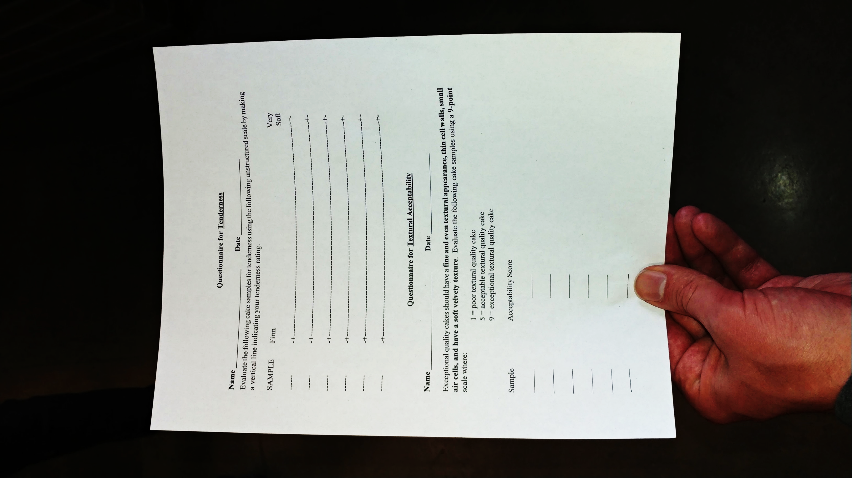**Document B**

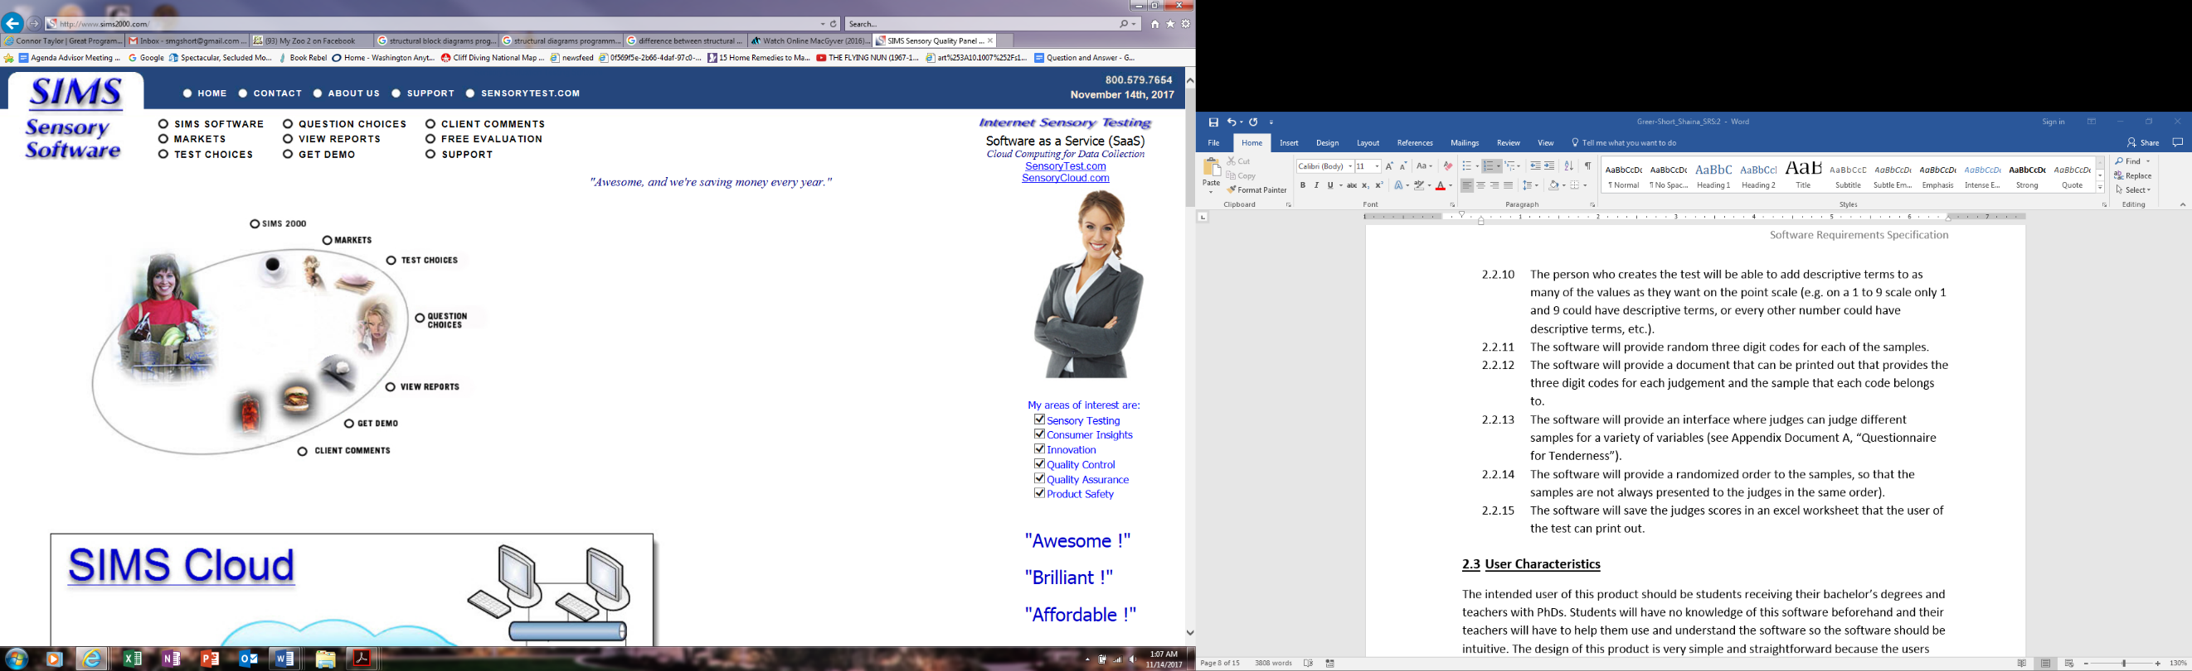A screen shot of the SIMS Sensory Software website.

The website is <http://www.sims2000.com/>.

**Document C**

This is a screen shot of the main page on the website we are creating. This screen shot was taken on an Android phone in the Chrome browser.

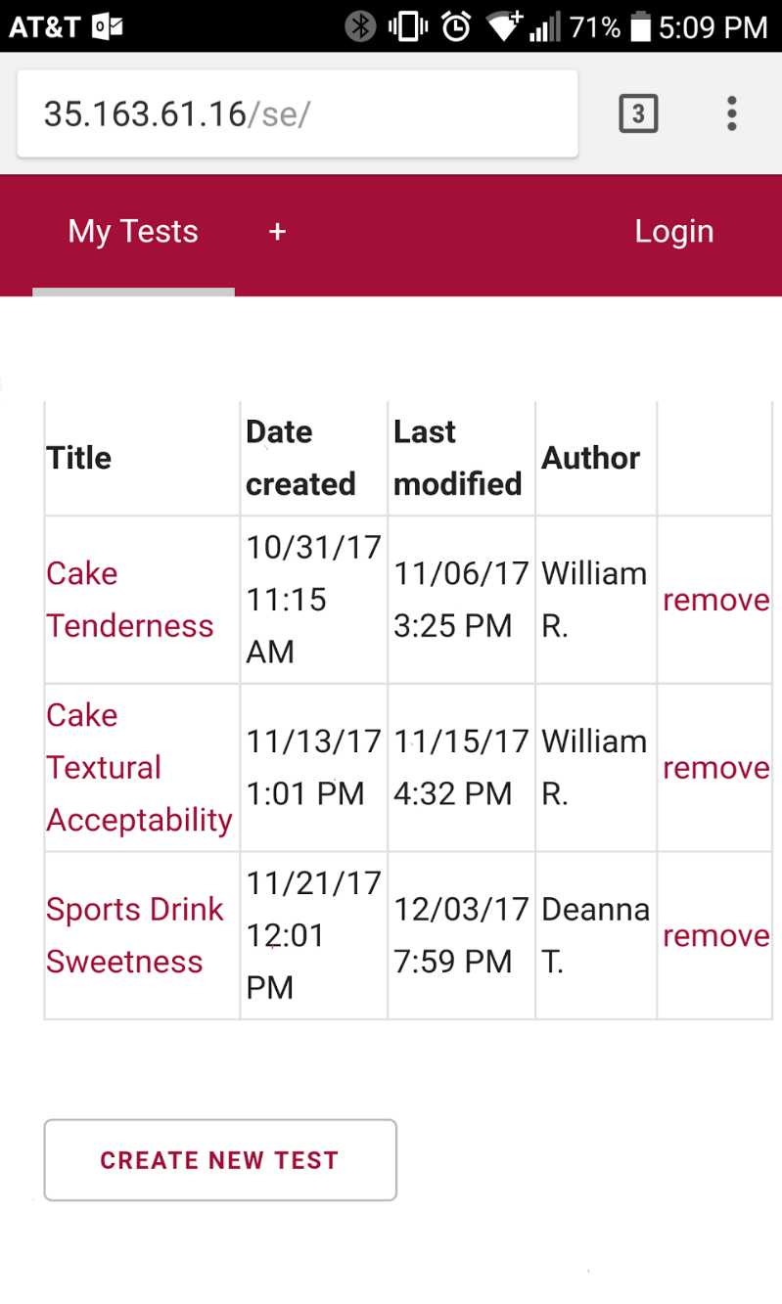

**Document D**

This is a screen shot of the main page on the website we are creating. This screen shot was taken on an iPad in the Safari browser.

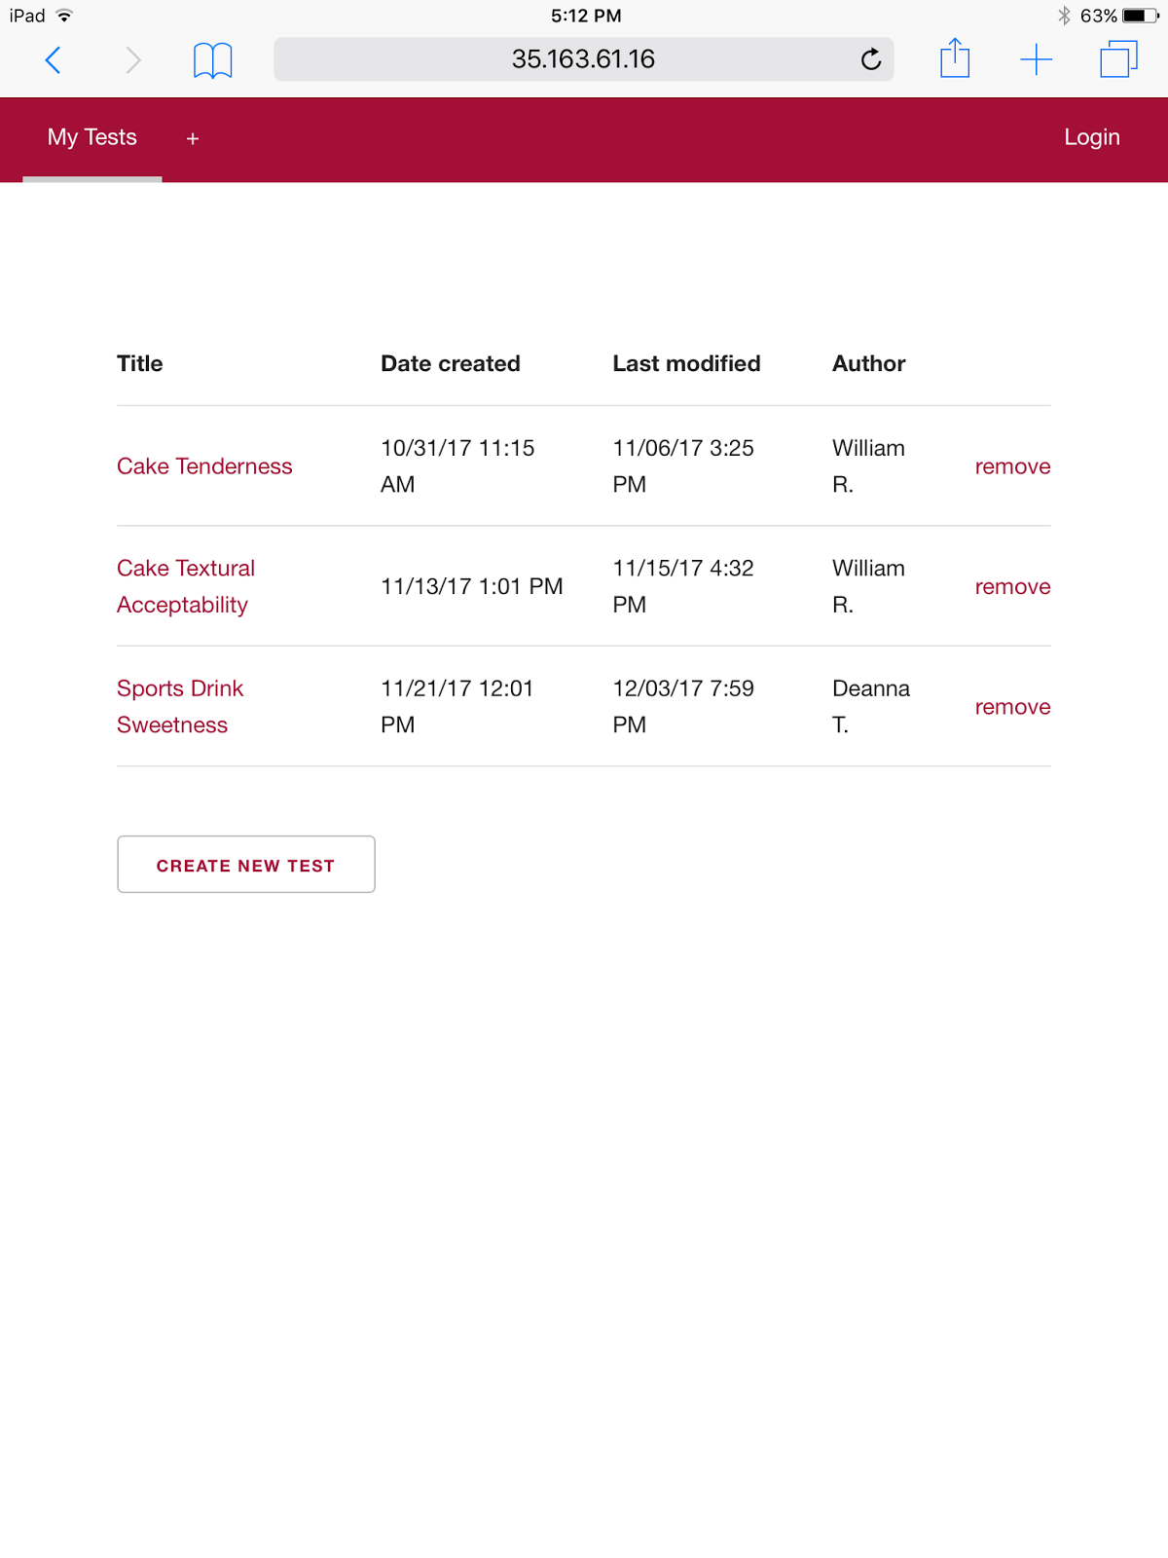

**Document E**

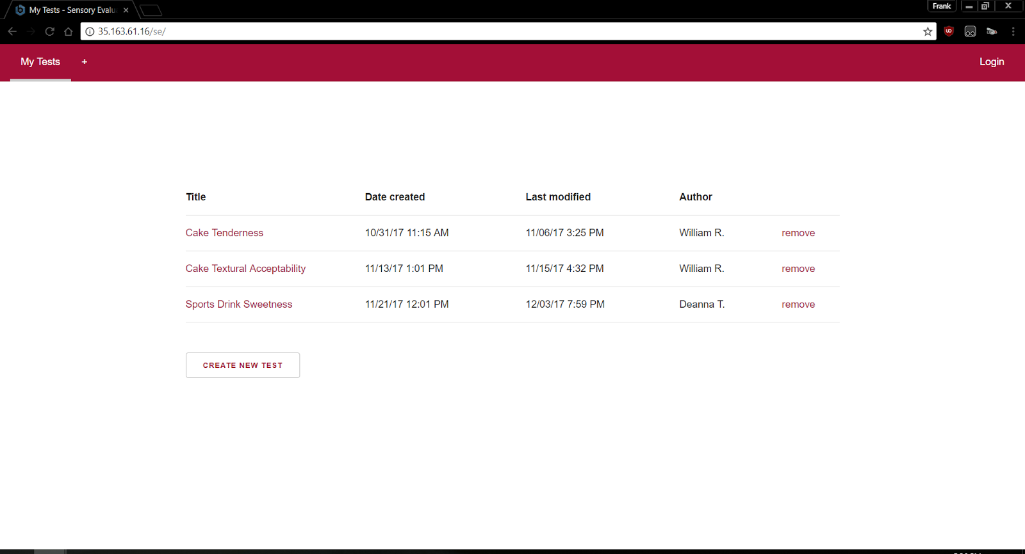This is a screen shot of the main page on the website we are creating. This screen shot was taken on a computer in the Chrome browser.